INSTITUTE OF TECHNICAL EDUCATION AND RESEARCH
(FACULTY OF ENGINEERING)
SIKSHA ‘O’ ANUSANDHAN (DEEMED TO BE UNIVERSITY), BHUBANESWAR,
ODISHA
i

Design A 16-bit Calculator (Arithmetic, Logical And Number System Conversion) Using 8086 Assembly Language
External Project Report on
Computer Organization and Architecture (EET 2211)


Submitted by

AMULYA SHRIVASTAVA | Reg. No.: | 2341019456
ANURAG PRADHAN | Reg. No.: | 2341016359
AMAAN AHMED | Reg. No.: | 2341001055
ISHAN ARYADIT | Reg. No.: | 2341001110
B. Tech. CSE 4th Semester (Section – 23412F3)

Declaration
We, The Undersigned Students Of B. Tech. Of CSE Department Hereby Declare That We Own The Full Responsibility For The Information, Results Etc. Provided In This Project Titled “Design An 16-Bit Calculator (Arithmetic, Logical And Number System Conversion) Using 8086 Assembly Language” Submitted To Siksha ‘O’ Anusandhan Deemed To Be University, Bhubaneswar For The Partial Fulfillment Of The Subject Computer Organization And Architecture (EET 2211). We Have Taken Care In All Respect To Honor The Intellectual Property Right And Have Acknowledged The Contribution Of Others For Using Them In Academic Purpose And Further Declare That In Case Of Any Violation Of Intellectual Property Right Or Copyright We, As The Candidate(s), Will Be Fully Responsible For The Same.

( AMULYA SHRIVASTAVA )
Registration No.: 2341019456
( ANURAG PRADHAN )
Registration No.: 2341016359

( AMAAN AHMED )
Registration No.: 2341001055
( ISHAN ARYADIT )
Registration No.: 2341001110

DATE: 20/05/2025
PLACE: I.T.E.R, SOA ( BHUBANESWAR )

Abstract
This Project Presents The Design And Implementation Of An 16-Bit Calculator Using 8086 Assembly Language, Capable Of Performing Arithmetic Operations, Logical Functions, And Number System Conversions. The Calculator Supports Basic Arithmetic Operations Including Addition, Subtraction, Multiplication, Division, And Remainder Calculation, While Also Incorporating Logical Operations Such As AND, OR, XOR, And NOT. In Addition To These Functions, The Calculator Effectively Converts Numerical Results Into Binary, Decimal And Hexadecimal Number Systems For Output Display. Developed Specifically For The Intel 8086 Microprocessor Architecture, The Program Utilizes Direct Register Manipulation And DOS Interrupts To Interact With The User Through Keyboard Input And Screen Output. The Implementation Ensures Robust Error Handling, Including Division By Zero Detection, To Maintain Program Stability. This Project Provides A Practical Understanding Of Low- Level Programming Concepts, Bitwise Operations, And Real-Time User Interaction In Assembly Language. It Acts As An Educational Tool For Those Interested In Exploring Computer Architecture, Embedded Systems, And The Inner Workings Of Computational Logic At The Hardware Level.

Contents

Serial  No. | Chapter No. | Title of the Chapter | Page No.
1. | 1 | Introduction | 01
2. | 2 | Problem Statement | 02
3. | 3 | Methodology | 03
4. | 4 | Implementation | 04-11
5. | 5 | Results And Interpretation | 12-14
6. | 6 | Conclusion | 15
7. |  | References | 16

- Introduction

The 8086 Microprocessor, Developed By Intel, Is A Powerful 16-Bit Processor That Laid The Foundation For X86 Architecture. Programming In 8086 Assembly Language Provides Valuable Insight Into Hardware-Level Computation, Precise Register Manipulation, And Direct Memory Access. This Project Focuses On Designing An 16-Bit Calculator Using 8086 Assembly Language, Supporting Arithmetic Operations Such As Addition, Subtraction, Multiplication, Division, And Modulus; Logical Operations Including AND, OR, XOR, And NOT; Along With Number System Conversions To Binary, Decimal, And Hexadecimal Formats. The Calculator Accepts Two 8-Bit Hexadecimal Inputs From The Keyboard And Uses DOS Interrupts For Input And Output Handling, Enabling Real-Time User Interaction. Each Operation Is Performed Using Low-Level Instructions With Proper Register Usage, Error Handling For Cases Like Division By Zero, And Bitwise Manipulation For Logical Results. Conversion Routines Are Carefully Implemented To Accurately Display Binary And Decimal Equivalents Of The Result. Through This Implementation, The Project Demonstrates The Efficiency And Transparency Of Low-Level Programming In Performing Fundamental Computational Tasks, Making It An Excellent Educational Tool For Understanding Microprocessor Architecture, Instruction-Level Execution, And Assembly Language Programming.

Problem Statement

The Objective Is To Design An 16-Bit Calculator Using 8086 Assembly Language That Performs Arithmetic Operations Such As Addition, Subtraction, Multiplication, Division, And Remainder Calculation, Along With Logical Operations Including AND, OR, XOR, And NOT. The Calculator Also Supports Number System Conversions, Displaying The Result In Binary, Decimal And Hexadecimal Formats. It Accepts Two 8-Bit Hexadecimal Digits As Input Through The Keyboard, Processes Them Using 8086 Instructions, And Displays The Output Using DOS Interrupts. Division By Zero Is Appropriately Handled With A Custom Error Message. This Project Demonstrates Practical Implementation Of Low-Level Programming Concepts, Including Register Operations, Bitwise Manipulation, And Direct Interaction With System Interrupts. It Enhances Understanding Of Microprocessor Functionality, Efficient Use Of CPU Registers, And Real-Time Execution In A DOS- Based Environment.

Methodology
Define Requirements: Identify And Categorize Required Operations— Arithmetic, Logical, And Number System Conversions.

Setup Environment: Use An Emulator Or Assembler Like MASM/TASM To Write And Test 8086 Assembly Code.

Input Handling: Capture 16-Bit User Input From The Keyboard Using DOS Interrupts (INT 21h).

Data Validation: Ensure Inputs Are Valid 16-Bit Values And Fall Within Acceptable Number System Formats.

Arithmetic Operations: Implement Addition, Subtraction, Multiplication, And Division Using 8086 Instructions.

Logical Operations: Program Bitwise Operations Such As AND, OR, XOR, And NOT.

Conversion Functions: Develop Routines To Convert Numbers Between Binary, Decimal And Hexadecimal.

Result Display: Use INT 21h Functions To Display Results Clearly On The Screen.

User Interface Loop: Create A Looped Menu System For Continuous User Interaction And Operation Selection.

Continuation Loop: Create A Looped Menu System Which Makes The User To Input Choices To Exit/Halt The Program Or Re-Run The Loop.

Testing And Debugging: Test Each Function Separately, Debug Errors, And Ensure Accurate Computation And Display.

Implementation
Here Is A Basic Implementation Of An 16-bit Calculator In 8086 Assembly Using EMU8086. It Includes A Simple Menu System, And Performs Arithmetic Operations, Logical Operations, And Number System Conversions For 16-bit Inputs.
The Assembly Code Is As Follows:
.model small
.stack 100h

.data
msg1 db 13, 10, 'Enter First Hex Digit (0-9, A-F): $' msg2 db 13, 10, 'Enter Second Hex Digit (0-9, A-F): $' msgAdd db 13, 10, 10, 'Addition: $'
msgSub db 13, 10, 'Subtraction: $'
msgMul db 13, 10, 'Multiplication: $' msgDiv db 13, 10, 'Division (Quotient): $' msgRem db 13, 10, 'Division (Remainder): $' msgAnd db 13, 10, 'AND: $'
msgOr db 13, 10, 'OR: $'
msgXor db 13, 10, 'XOR: $' msgNot1 db 13, 10, 'NOT Of First: $'
msgNot2 db 13, 10, 'NOT Of Second: $' msgBin1 db 13, 10, 10, 'First In Binary: $' msgBin2 db 13, 10, 'Second In Binary: $' msgDec1 db 13, 10, 'First In Decimal: $' msgDec2 db 13, 10, 'Second In Decimal: $' newline db 13, 10, '$'
hexChars db '0123456789ABCDEF'
divByZero db 13, 10, 'Division By Zero!', 13, 10, '$'
promptRepeat db 13, 10, 10, 'Enter 0 To Exit Or 1 To Repeat: $'

.code main:
mov ax, @data mov ds, ax

program_loop:
; Print Message 1 And Read First Hex Digit lea dx, msg1
mov ah, 09h int 21h
call ReadHex

mov bl, al ; Store First Number In BL

; Print Message 2 And Read Second Hex Digit lea dx, msg2
mov ah, 09h int 21h
call ReadHex
mov bh, al ; Store Second Number In BH

; ----------- ARITHMETIC OPERATIONS -----------
; Addition
lea dx, msgAdd mov ah, 09h int 21h
mov al, bl add al, bh call PrintHex

; Subtraction lea dx, msgSub mov ah, 09h int 21h
mov al, bl sub al, bh call PrintHex

; Multiplication lea dx, msgMul mov ah, 09h int 21h
mov al, bl
mov ah, 0 ; Clear AH For Multiplication mul bh ; AX = AL * BH
call PrintHex ; Prints AL (Lower Byte Of Result)

; Division (With Check For Division By Zero) lea dx, msgDiv
mov ah, 09h int 21h
cmp bh, 0
je divisionError

mov al, bl mov ah, 0
div bh ; AL = Quotient, AH = Remainder

mov cl, ah ; Store Remainder

; Print Quotient call PrintHex

; Print Remainder lea dx, msgRem mov ah, 09h
int 21h mov al, cl
call PrintHex
jmp afterDivision ; Skip Error Label divisionError:
lea dx, divByZero mov ah, 09h
int 21h

afterDivision:
; ----------- LOGICAL OPERATIONS -----------
; AND
lea dx, msgAnd mov ah, 09h int 21h
mov al, bl and al, bh call PrintHex

; OR
lea dx, msgOr mov ah, 09h int 21h
mov al, bl or al, bh
call PrintHex

; XOR
lea dx, msgXor mov ah, 09h int 21h
mov al, bl xor al, bh call PrintHex

; NOT (First Number) lea dx, msgNot1 mov ah, 09h
int 21h mov al, bl not al
and al, 0FFh ; Mask To 8 Bits call PrintHex

; NOT (Second Number) lea dx, msgNot2
mov ah, 09h int 21h
mov al, bh not al
and al, 0FFh ; Mask to 8 bits call PrintHex

; ----------- NUMBER SYSTEM CONVERSIONS -----------
; First Number In Binary lea dx, msgBin1
mov ah, 09h int 21h
mov al, bl
call PrintBinary

; Second Number In Binary lea dx, msgBin2
mov ah, 09h int 21h
mov al, bh
call PrintBinary

; First Number In Decimal lea dx, msgDec1
mov ah, 09h int 21h
mov al, bl
call PrintDecimal

; Second Number In Decimal lea dx, msgDec2
mov ah, 09h int 21h

mov al, bh
call PrintDecimal

; Ask User If They Want To Repeat lea dx, promptRepeat
mov ah, 09h int 21h

; Read User Choice mov ah, 01h
int 21h

cmp al, '1'
je program_loop ; Repeat If Input Is '1'

; Exit Program If Input Is Not '1' mov ah, 4Ch
int 21h

; Subroutine: ReadHex
; Reads One Hex Digit (0-9, A-F) And Converts To Number (0-15)
; Returns: AL = Numeric Value (0-15) ReadHex:
mov ah, 01h
int 21h ; Input Character In AL

; Convert ASCII To Hex Value cmp al, '0'
jb InvalidChar cmp al, '9' jbe Digit
cmp al, 'A'
jb InvalidChar cmp al, 'F'
jbe AlphaUpper cmp al, 'a'
jb InvalidChar cmp al, 'f'
jbe AlphaLower

InvalidChar:
mov al, 0 ; Default To 0 On Invalid Input ret

Digit:

sub al, '0' ; Convert '0'-'9' To 0-9 ret

AlphaUpper:
sub al, 'A' ; Convert 'A'-'F' To 10-15 add al, 10
ret

AlphaLower:
sub al, 'a' ; Convert 'a'-'f' To 10-15 add al, 10
ret

; Subroutine: PrintHex
; Prints AL (16-Bit Value) In 2-HEX PrintHex:
push ax push bx push cx push dx

mov cl, al ; Save Original Value
lea bx, hexChars ; Point To Hex Character Table

; High Nibble mov al, cl shr al, 4
and al, 0Fh ; Ensure Only 4 Bits
xlat ; Convert To Hex Character mov dl, al
mov ah, 02h int 21h

; Low Nibble mov al, cl and al, 0Fh
xlat ; Convert To Hex Character mov dl, al
mov ah, 02h int 21h

pop dx pop cx pop bx pop ax

ret

; Subroutine: PrintBinary
; Prints AL (8-bit Value) In Binary Format PrintBinary:
push ax push bx push cx push dx

mov bl, al ; Save Original Value mov cx, 8 ; 8 Bits To Print

PrintBit:
rol bl, 1 ; Rotate Left Through Carry mov dl, '0'
jnc PrintZero mov dl, '1'
PrintZero: push ax mov ah, 02h int 21h
pop ax
loop PrintBit

pop dx pop cx pop bx pop ax ret

; Subroutine: PrintDecimal
; Prints AL 16-bit Value In Decimal Format PrintDecimal:
push ax push bx push cx push dx

mov bl, al ; Save Original Value mov ah, 0 ; Clear AH For Division
mov al, bl ; Restore Value To AX (AH=0, AL=value)

; Handle 3 Digits (0-255)
mov cl, 100

div cl ; AL = Hundreds Digit, AH = Remainder mov ch, ah ; Save Remainder
add al, '0' ; Convert To ASCII mov dl, al
mov ah, 02h
int 21h ; Print Hundreds Digit

mov al, ch ; Restore Remainder mov ah, 0
mov cl, 10
div cl ; AL = Tens Digit, AH = Units Digit mov bx, ax ; Save Both Digits

add bl, '0' ; Convert Tens To ASCII mov dl, bl
mov ah, 02h
int 21h ; Print Tens Digit

add bh, '0' ; Convert Units To ASCII mov dl, bh
mov ah, 02h
int 21h ; Print Units Digit

pop dx pop cx pop bx pop ax ret

end main

Results & Interpretation

Result -1 :
Let’s Assume You Enter The Following Characters When Prompted:
  - First Digit: 9 (In Hexadecimal)
  - Second Digit: 5 (In Hexadecimal)
  - Choice To Exit Or Continue: 0
Output :

Result – 2 :
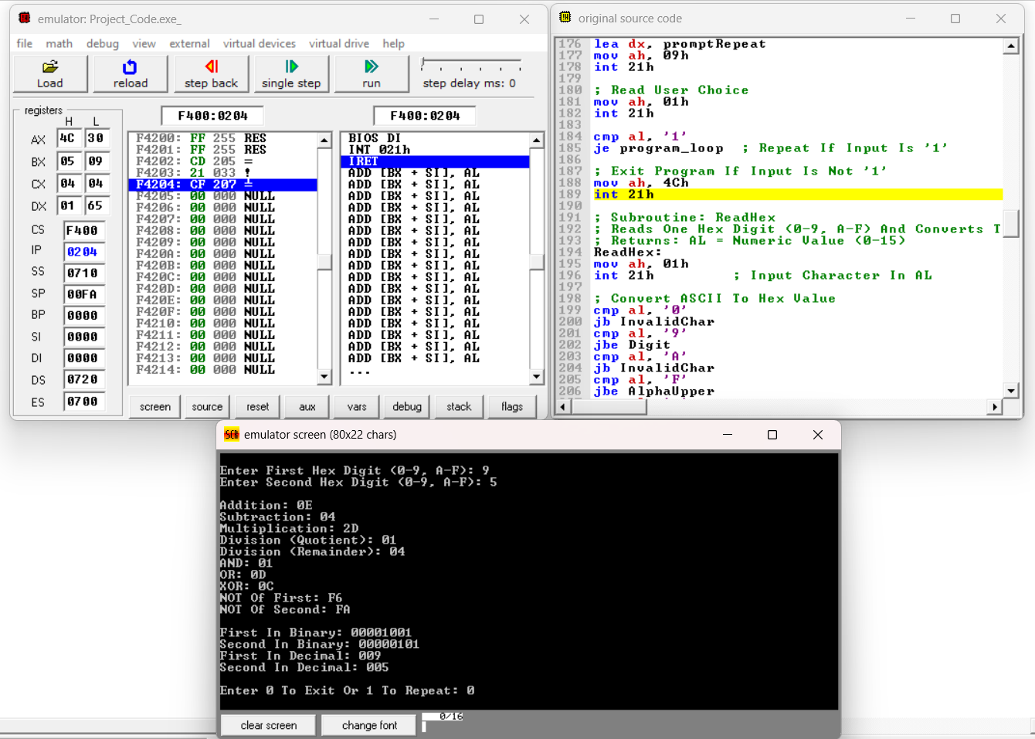
Let’s Assume You Enter The Following Characters When Prompted:
  - First Digit: 4 (In Hexadecimal)
  - Second Digit: 7 (In Hexadecimal)
  - Choice To Exit Or Continue: 1

Output :

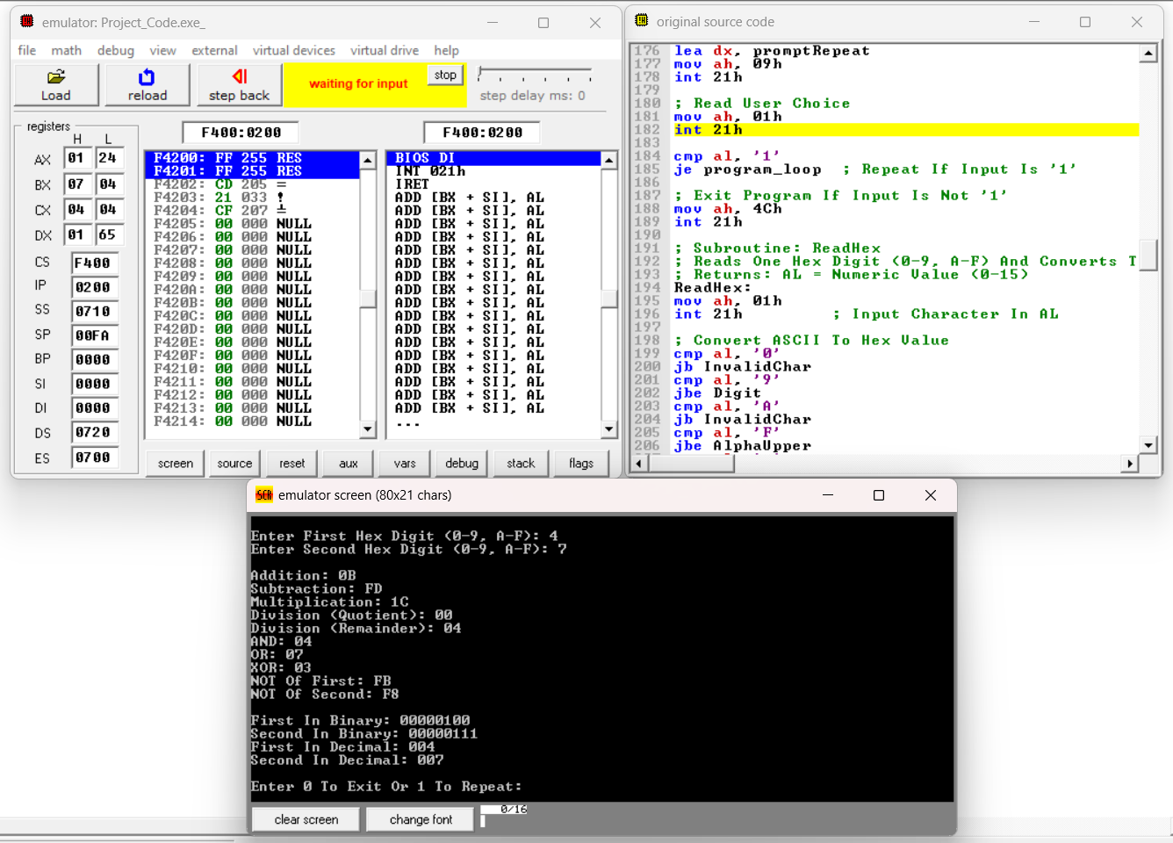

Let’s Assume You Enter The Following Characters When Prompted:
  - First Digit: 5 (In Hexadecimal)
  - Second Digit: 5 (In Hexadecimal)
  - Choice To Exit Or Continue: 0
Output :
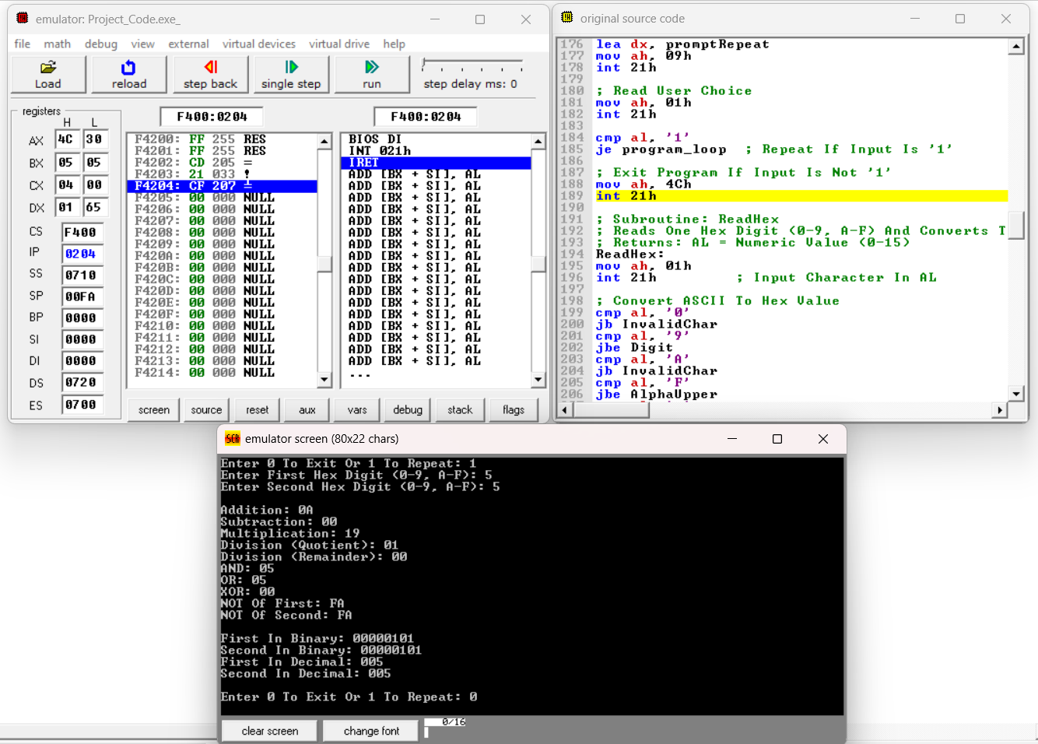

Result – 3 :
Let’s Assume You Enter The Following Characters When Prompted:
  - First Digit: 4 (In Hexadecimal)
  - Second Digit: 0 (In Hexadecimal)
  - Choice To Exit Or Continue: 0
Output :
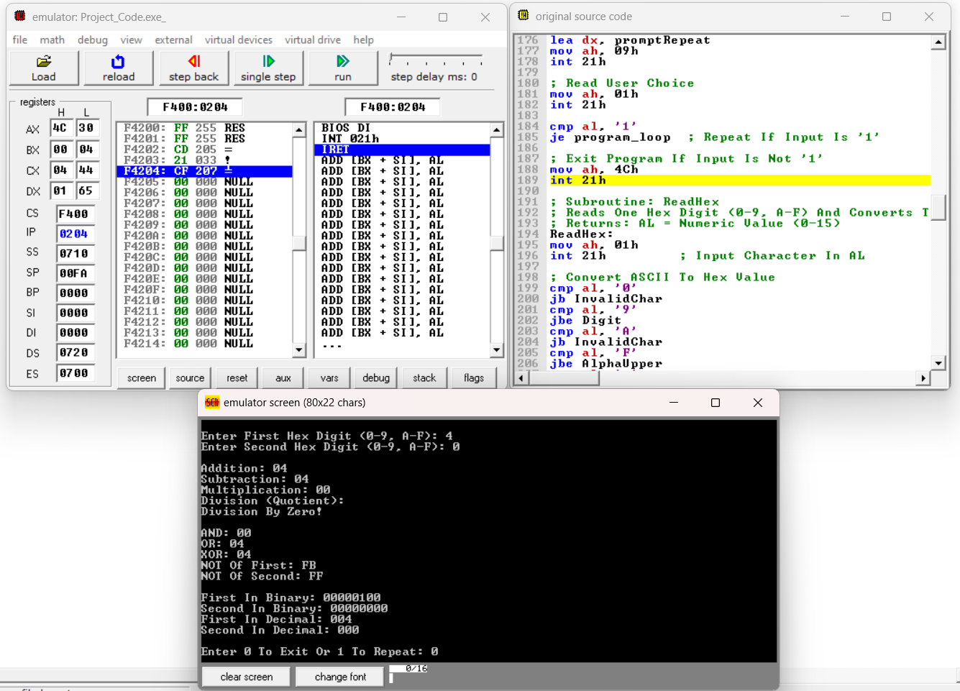

Conclusion
The Design And Implementation Of An 16-Bit Calculator Using 8086 Assembly Language Effectively Demonstrate The Capabilities And Limitations Of Low-Level Programming For Arithmetic, Logical Operations, And Number System Conversions. This Project Highlights How Fundamental Computational Tasks Such As Addition, Subtraction, Bitwise Operations (AND, OR, XOR, NOT), And Conversions Between Binary, Decimal, And Hexadecimal Can Be Directly Controlled And Executed By The Processor. By Using Assembly Language, The Program Ensures Efficient Use Of CPU Registers And Memory, Giving Insight Into How Hardware-Level Operations Are Performed. The Project Also Reinforces The Understanding Of Interrupt-Driven Input/Output Through DOS Services, Allowing Interaction With Users Via Keyboard And Screen.
Despite Its Simplicity, This Calculator Serves As An Educational Tool To Appreciate The Complexity Behind High-Level Calculator Applications And Emphasizes The Importance Of Data Representation In Computer Systems. Handling Number System Conversions Within 8086 Assembly Deepens Comprehension Of Binary Arithmetic And Encoding, Which Is Critical For Embedded Systems And Hardware Design. Although Modern Systems Rely On Higher-Level Languages For Such Tasks, Mastering These Assembly Concepts Builds A Strong Foundation In Computer Architecture And System Programming. Overall, The Project Successfully Integrates Arithmetic, Logical, And Conversion Functions Into A Compact, Interactive Program, Showcasing The Practical Use Of 8086 Assembly In Real-World Applications.

References
( As Per The IEEE Recommendations)

- Intel Corporation, Intel® 64 And IA-32 Architectures Software Developer’s Manual, Vol. 1, 2019.

- R. Hyde, The Art Of Assembly Language, 2nd Ed. San Francisco, CA, USA: No Starch Press, 2010.
- M. Beck, “8086 Assembly Language Programming Tutorial,” 2021. Available.

- J. S. Irvine, Assembly Language For Intel-Based Computers, 6th Ed. Boston, MA, USA: Pearson, 2012.

